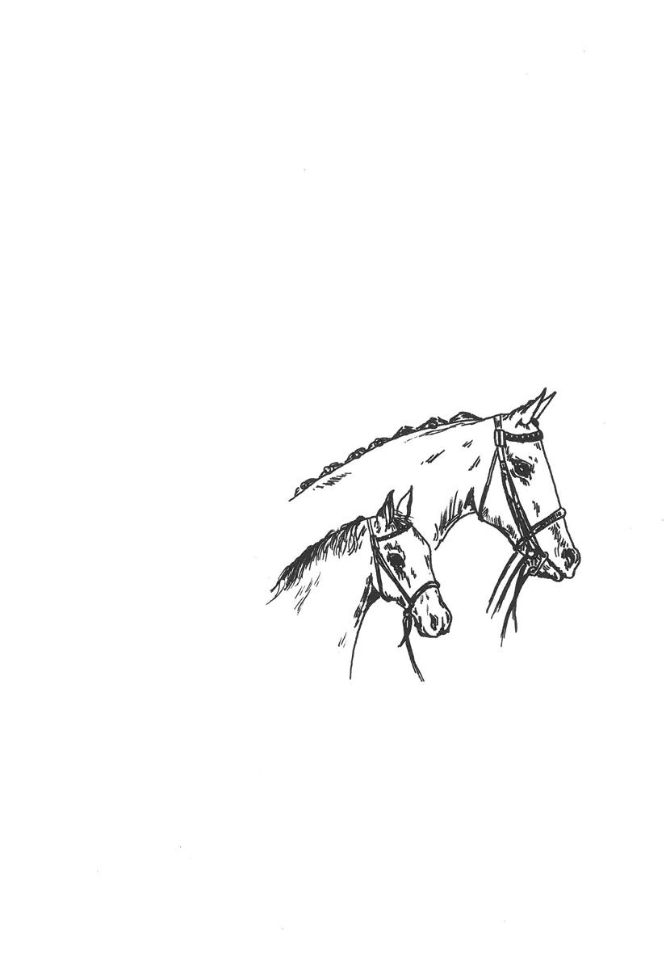

NCPA LEICESTER AND RUTLAND BRANCH

13th August 2023

To be held at Newark & Notts County Showground, Winthorpe, Newark, Notts. NG24 2NY

All enquires to:
Sandra Moncaster, Byeways, Saxilby Lane, Broadholme, Lincoln LN1 2ND 01522 704210 / 07974 568992 (NO TEXT MESSAGES PLEASE)

THE SHOWGROUND GATES WILL NOT OPEN BEFORE 7AM

NCPA affiliation number (62/23)

Qualifiers for the 2023 NCPA GOLDEN SUPREMES
Prize monies at the final £500, £300, £100, £50, £25, £25 for each
***NCPA TOPLINE HORSEBOXES Junior Mountain & Moorland Qualifier***

PRE ENTRIES CLOSE: 9th August 2023
ONLINE: NCPA Members £6 Non-members £10

ENTRIES ON THE DAY £15

First Aid £3

***This show is a qualifier for the NCPA Pony of The Year held in Sept 2023. 1st, 2nd & 3rd prize winners will qualify.***

***This show is a qualifier for the NCPA GOLDEN SUPREMES held in Sept 2023. ALL Champion & Reserve Champion animals & 1st Prize winner in each NCPA Topline Horseboxes Junior ridden classes will qualify.***

***This show is a qualifier for the NCPA President’s Cup In Hand Final held in September 2023. The NCPA Registered In Hand Champion & Reserve will qualify.***

***This show is a qualifier for the NCPA Chairman’s Cup In Hand Final held in September 2023. The NCPA Registered Ridden Champion & Reserve will qualify.***

HEALTH & SAFETY The Safety & Security of persons and animals attending this show is of paramount importance to the organisers of this show. Competitors and all those attending the show are reminded of their obligations under Health & Safety legislation to adhere to the safety instructions of stewards and officials at all times and to adhere to written instruction and signs relating to safety, for example; horse walks, and pedestrian areas, for their own safety and the safety of others who may be affected by their acts or omissions to act. All accidents must be reported to the Health & Safety officer, Mark Moncaster, who can be contacted through the Show Secretary's office and the Accident Record must be completed. Neither the NCPA Notts/Lincs Branch Committee, nor any of its Officers, Servants, or Assistants shall be responsible or accountable for any loss, injury or damage to any person, animal, or property, or vehicle in connection with this Show. We ask that all exhibitors have third party insurance on themselves and their horse/pony before attending or competing at the show.

• Neither the N.C.P.A or any of its officers, assistants or stewards shall in any way be responsible for any loss, injury or damages that may happen to exhibitors or their assistants or other members of the public, or to any animal or property or to any vehicle brought into the Showground or on any premises used in conjunction with the Show, or while entering or leaving the same.

It is necessary all exhibitors carry Public Liability Insurance for an adequate indemnity to protect against their negligence including any injury caused by their animals or property.

SHOW RULES The organisers of the show have taken reasonable precautions to ensure the Health & Safety of everyone present. For these measures to be effective, everyone must take all reasonable precautions to avoid and prevent accidents occurring and must obey the instructions of the organisers and all the Officials & Stewards. Competitors must abide by ALL the Society Rules at all times. IT IS THE RULE OF NEWARK SHOWGROUND AND THE N.C.P.A that a correctly secured Skull Caps/Riding Hats Nos PAS015 2011, VGI, (BS) EN1384 2017, ASTM F1163 04a onwards, SNELLE2016, AS/NZS 3838 2006 onwards MUST Be worn by competitors, riders and judges at ALL TIMES whilst mounted.

It is a condition of entry that Exhibitors agree to be bound by the rules herewith under. Any objection must be made in writing with a deposit of £50.00 in cash, (refundable if the objection is upheld),within 30 minutes of the class taking place.

The organising Committee accept no responsibility whatsoever for any loss, injury or damage to any person or their property whilst on the showground, car parks or approaches.

THE N.C.P.A DOES NOT allow anyone to bring their horses or ponies to ride or walk around at the show WITHOUT entering a class due to the N.C.P.A Public liability INSURANCE Ruling. Anyone found to be breaking this rule will be asked to leave the showground immediately.

Entry fees will not be refunded and it is the responsibility of the exhibitor to ensure that their entry is correct, eligible and available when called for their class. Exhibitors must take into consideration that classes may clash. If this occurs, they must nominate which class they wish to compete in. No classes will be held up for any competitor.

Entries for affiliated classes will also be bound by the Rules and Conditions in force at the time of showing, applicable to that Association and the class in which they are exhibiting. It is deemed by the organising Committee that exhibitors are conversant with any such rules, conditions or directives. The organising Committee reserve the right to amalgamate or split classes and alter or amend the running order of classes. In the event of a show being cancelled, entry fees, less a £10.00 deduction for administration charges, will be refunded.
Any person who is found to be abusive, violent, aggressive, towards any official connected to this Show will be asked to leave the showground IMMEDIATELY
Horses/ponies must be attended at all times when tied to the outside of a lorry or trailer.

WHP Junior riders MUST be accompanied by an adult in the collecting ring when using the practice fence.
First Aid in Attendance

EQUINE FLU ALL HORSE & PONIES MUST HAVE A VALID UP TO DATE YEARLY EQUINE INFLUENZA CERTIFICATE AND PASSPORTS MUST BE CARRIED WITH THE CORRECT HORSE OR PONY BY LAW. RANDOM PASSPORTS INSPECTION WILL BE TAKING PLACE

RING ONE Working Hunter 9:30am

Judge: Mrs C Scott

Class 1 Lead rein working hunter pony: Plaited or M&M ponies, 4 yrs old & over Max height of fence 30cm

Class 2 50cms NCPA Worker Stakes: Plaited or M&M ponies, 4 yrs old & over not exc 158cms. Riders any age but must be suitably mounted for the pony/horse they ride.
Class 3 60cms NCPA Worker Stakes: Plaited or M&M ponies, 4 yrs old & over not exc 158cms. Riders any age but must be suitably mounted for the pony/horse they ride.
Class 4 70cms NCPA Worker Stakes: Plaited or M&M ponies, 4 yrs old & over not exc 158cms. Riders any age but must be suitably mounted for the pony/horse they ride.
Class 5 80cms NCPA Worker Stakes: Plaited or M&M ponies, 4 yrs old & over not exc 158cms. Riders any age but must be suitably mounted for the pony/horse they ride.
Class 6 90cms NCPA Worker Stakes: Plaited or M&M ponies, 4 yrs old & over not exc 158cms. Riders any age but must be suitably mounted for the pony/horse they ride.
Class 7 100cms NCPA Worker Stakes: Plaited or M&M ponies, 4 yrs old & over not exc 158cms. Riders any age but must be suitably mounted for the pony/horse they ride.

NOT BEFORE 1:00PM

Class 8 NCPA open working hunter 4 yrs old & over exc 153cms. Riders any age but must be suitably mounted for the pony/horse they ride. Max height of fence 80cm
Class 9 NCPA open working pony 4 yrs old & over not exceeding 153. Riders any age but must be suitably mounted for the pony/horse they ride. Max height of fence 60cm
Class 10 Nursery Stakes: Plaited or M&M ponies, Mare or Gelding, 4 yrs old or over not exc 133cm. Riders not to have attained their 12th birthday before 1st Jan of the current year. Max height of fence 60cm
Class 11 Cradle Stakes: Plaited or M&M ponies, Mare or Gelding, 4 yrs old or over not exc 122cm. Riders not to have attained their 11th birthday before 1st Jan of the current year. Max height of fence 50cm

RING TWO Ridden 9.30am

Judge: Mrs S Hatton

Class 12 NCPA Registered Large Breeds: Stallion, Mare or Gelding, 4yrs and over. Rider any age.
Class 13 NCPA Registered Small Breeds: Lead rein included Stallion, Mare or Gelding, 4yrs and over. Rider any age.
Class 14 NCPA Registered Non M&M: lead rein included Stallion, Mare or Gelding 4yrs and over, not exc. 148cms. Rider to be suitable size for the pony.
Class 15 NCPA Registered Non M&M: Stallion, Mare or Gelding, 4yrs and over exc. 148cms.

Championship: 1st & 2nd Prize winners from classes 12-15 to compete. Champion and Reserve to qualify for THE CHAIRMAN’S CUP held at the Pony of the Year show, sept 2023.

Class 16 NCPA Ridden Veteran: stallion, mare or gelding 15yrs and over, rider any age.
Class 17 NCPA Hack/Riding Horse: mare or gelding 4yrs and over, rider any age.
Class 18 NCPA Native/Cob Coloured: stallion, mare or gelding 4yrs and over, rider any age.
Class 19 NCPA Non-Native Coloured: stallion, mare or gelding 4yrs and over, rider any age.

NOT BEFORE 12:30PM

Class 20 NCPA part-bred horse: mare or gelding 4yrs and over, rider any age. exc 148
Class 21 NCPA part-bred pony: mare or gelding 4yrs and over, rider any age.not exc 148
Class 22 NCPA Ridden Cob: mare or gelding 4yrs and over, rider any age.
Class 23 NCPA Ridden Hunter: mare or gelding 4yrs and over, rider any age.
Class 24 NCPA Hunter Pony Ridden: not exc 153, mare or gelding 4yrs and over, rider any age.
Class 25 NCPA Show Pony Ridden: not exc 148, mare or gelding 4yrs and over, rider any age.
Class 26 NCPA M&M Ridden: Small Breeds, Stallion, Mare or Gelding 4yrs and over.
Class 27 NCPA M&M Ridden: Large Breeds, Stallion, Mare or Gelding 4yrs and over.

CHAMPIONSHIP- 1st & 2nd prize winners from classes 16-27

RING THREE Children 10:00am

Judge: Mrs D Gregson

Class 28 NCPA young handler Aged 3 to 9 years (Parent may accompany the child in the class) Mare or Gelding 4 years old and over. Rosettes to all competitors
Class. 29 NCPA young handler Aged 10 to 16 years Mare or Gelding 4 years old and over. Rosettes to all competitors

Championship- 1st and 2nd prize winners from class 28 & 29

Class 30 NCPA walk and trot: mare or gelding 4yrs and over, Riders not to have attained their 12th birthday before 1st Jan in the current year.
Class 31 NCPA Tiny Tots M&M Lead Rein: Registered Pure Bred Mare or Gelding 4yrs old and over, not exc 122cm. Riders not to have attained their 5th birthday before 1st Jan in the current year.
Class 32 NCPA Tiny Tots M&M First Ridden: Registered Pure Bred Mare or Gelding 4yrs old and over, not exc 128cm. Riders not to have attained their 8th birthday before 1st Jan in the current year.
Class 33 NCPA Tiny Tots Lead Rein: Registered Pure Bred Mare or Gelding 4yrs old and over, not exc 122cm. Riders not to have attained their 5th birthday before 1st Jan in the current year.
Class 34 NCPA Tiny Tots First Ridden: Registered Pure Bred Mare or Gelding 4yrs old and over, not exc 128cm. Riders not to have attained their 8th birthday before 1st Jan in the current year.

NOT BEFORE 1:00PM

Class 35 NCPA M&M Lead Rein: Registered Pure Bred Mare or Gelding 4yrs old and over, not exc 122cm. Riders not to have attained their 9th birthday before 1st Jan in the current year.
Class 36 NCPA M&M First Ridden: Registered Pure Bred Mare or Gelding 4yrs old and over, not exc 128cm. Riders not to have attained their 12th birthday before 1st Jan in the current year.
Class 37 NCPA Lead Rein Show/Show Hunter Ponies: Mare or Gelding 4 yrs old and over not exc 122cms. Riders to have attained their 3rd birthday but not to have attained their 8th (Show Ponies) or 9th birthday (Show Hunter Ponies) before 1st Jan. in the current year.
Class 38 NCPA First Ridden Show/Show Hunter Ponies: Mare or Gelding 4 yrs old and over not to exc 122cms. Riders not to have attained their 10th birthday before the 1st Jan. in the current year

Mini championship- 1st & 2nd prize winners from classes 30-38.

Class 39 NCPA Riding Club Pony: mare or gelding 4yrs and over, Riders not to have attained their 12th birthday before 1st Jan in the current year.
Class 40 Fancy Dress: Hard Hats MUST Be Worn
Class 41 NCPA TOPLINE HORSEBOXES Junior Mountain & Moorland Ridden Small Breeds: Registered Pure Bred Dartmoor, Exmoor, Shetland, Welsh A & B Mares or Geldings 4yr old or over. Riders not to have attained their 14th birthday by the 1st of January in the current year.
Class 42 NCPA TOPLINE HORSEBOXES Junior Mountain & Moorland Ridden Large Breeds: Registered Pure Bred Connemara, Dales, Fell, Highland, New Forest, Welsh C & D Mares or Geldings 4yr old or over. Riders not to have attained their 18th birthday by the 1st of January in the current year.

RING 4 In Hand 9:00am
Judge: Mrs H Horsfall

Class 43 NCPA Registered M&M: Stallion, Mare or Gelding 4yrs and over.
Class 44 NCPA Reg Non M&M: Stallion, Mare or Gelding 4yrs and over.
Class 45 NCPA Registered M&M: Yearling, 2 & 3 yr old Colt, Filly or Gelding.
Class 46 NCPA Registered Non M&M: Yearling, 2 & 3 yr old Colt, Filly or Gelding.

Championship- 1st & 2nd prize winners from classes 43-46. Champion and Reserve to qualify for The Presidents Cup held at the Pony of the Year show, sept 2023.

Class 47 M&M Small Breeds: Stallion, Mare or Gelding 4yrs and over
Class 48 M&M Large breeds: Stallion, Mare or Gelding 4yrs and over
Class 49 Connemara Tam O’Shanter qualifier: Connemara Mare 4yrs and over not exc 148cms
Class 50 M&M Small Breeds Youngstock: Yearling, Two or Three year old Colt, Filly or Gelding
Class 51 M&M Large Breeds Youngstock: Yearling, Two or Three year old Colt, Filly or Gelding
Class 52 Connemara Tam O’Shanter Yearling qualifier: Connemara Colt, Filly or Gelding not to exc 148cms at maturity
Class 53 Connemara Tam O’Shanter Two Year Old qualifier: Connemara Colt, Filly or Gelding not to exc 148cms at maturity
Class 54 Riding Pony/Hunter Pony: Stallion, Mare or Gelding 4yrs and over
Class 55 Riding Pony/Hunter Pony Youngstock: Yearling, Two or Three year old Colt, Filly or Gelding
Class 56 Horse: Cobs, Hack Type, Riding Horse and Hunters: Stallion, Mare or Gelding 4yrs and over
Class 57 Horse: Exc 148 Youngstock: Yearling, Two or Three year old Colt, Filly or Gelding

Championship- 1st & 2nd prize winners from classes 47- 57

NOT BEFORE 12:30PM

Class 58 Part Bred Pony: Stallion, Mare or Gelding 4yrs and over not exc 148cms
Class 59 Part Bred Horse: Stallion, Mare or Gelding 4yrs and over exc 148cms
Class 60 Native Coloured: Stallion, Mare or Gelding 4yrs and over any height
Class 61 Native Youngstock: Yearling, Two or Three year old Colt, Filly or Gelding any height
Class 62 Non Native: Stallion, Mare or Gelding 4yrs and over any height
Class 63 Non Native Youngstock: Yearling, Two or Three year old Colt, Filly or Gelding any height
Class 64 Veterans: Stallion, Mare or Gelding 15yrs and over
Class 65 Owner Bred Pony: Stallion, Mare , Colt, Filly or Gelding, any age, not exc 148cms
Class 66 Owner Bred Horse: Stallion, Mare, Colt, Filly or Gelding, any age exc 148cms
Class 67 Owner Bred M&M: Stallion, Mare , Colt, Filly or Gelding, any age

Championship- 1st & 2nd prize winners from classes 58-67

